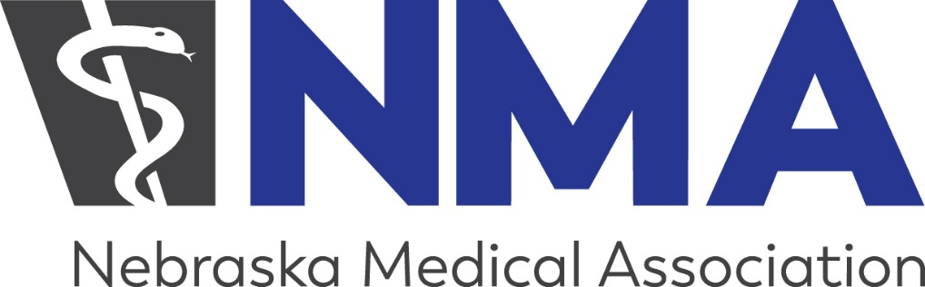

NEBRASKA MEDICAL ASSOCIATION PHYSICIAN LEADERSHIP ACADEMY

Application for Participation

Name:
Address:
Specialty/Practice location:
Email address:
Phone:

Please attach a one page description of your interest in the Academy. If you are selected, the Academy will require one half day of participation each month from September 2018 – June 2019. The dates of the meetings, which will be held in the NMA office in Lincoln from 8 a.m. – noon, are included in this packet.

The Academy is free to each participant as a result of a generous grant from the Physicians Foundation to the Nebraska Medical Foundation. Our only request is each participant will commit to attend all 10 curriculum sessions once selected and will meet intermittently with our facilitator between sessions as needed.

Please complete form or indicate your intent to participate to Dale at dalem@nebmed.org by Friday, July 13.

